35.4: a) The path difference is 120 m, so for destructive interference:
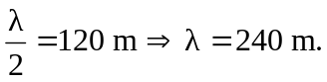
b) The longest wavelength for constructive interference is 